NEXTAG COMPANY

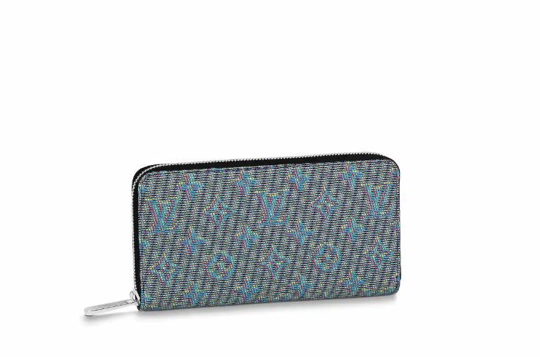LOUIS VUITTON - ZIPPY WALLET

##### **Detail**

For Fall-Winter 2019, Nicolas Ghesquière brings the Monogram LV Pop motif to the Zippy Wallet’s calf leather. Inspired by the distinctive colorway of the Centre Pompidou museum in Paris, the pattern has a neon, 3-D effect that brings modernity to the wallet. The interior array of pockets, compartments, and card slots make it practical.

• Monogram LV Pop Blue

• Printed calf leather

• Calf-leather trim

• Microfiber lining

##### • 19.5 x 10.5 x 2.5 cm (Length x Height x Width)

##### **CARE & COMPOSITION**

* leather
* imported